 

**AMITY INSTITUTE OF BIOTECHNOLOGY**

**BIOPHYSICS AND STRUCTURAL BIOLOGY**

**PRACTICAL FILE**

**Submitted by- Submitted to-**

**Name:** Sharvin Varghese **Dr Sarika Saxena**

**Course:** B.Tech & M.Tech Integrated

**Section:** D

**Batch:** 2018-23

**Enrollment number:** A005116518027

**Roll number:** BTBM/18/122

**Experiment-1**

**Aim-**

1. Preparation of aqueous solution.
2. Precautions while using a weighing balance.
3. Calibrationof pH meter
4. Preparation of buffer solution
5. **Preparation of aqueous solution-**

**Theory-**

**Solution-** It is a homogeneous mixture of one or more solutes dissolved in a solvent.

**Solvent-** It is the substance that is present in the high amount. It can be gas, liquid or solid.

**Solute-** It is the substance present in the least amount. It can be gas, liquid or solid.

**Concentration of a solution-** It is defined as the amount of a biomolecule per unit volume.

**Concentration of a solution can be measured in following ways-**

1. **Molarity(M)-**

It is defined as number of moles of solute per litre of solution.

If the solute is a solid:

E.g., To prepare 1M NaOH 100ml

w = 4g

4 g of NaOH will be weighed and dissolved in 50 ml of water in a conical flask. Shake it till all particles will be dissolved and then make up the volume to 100 ml.

If the solute is a liquid:

M1V1=M2V2

Where,

M1 = Molarity of Stock Solution

V1 = Volume of Stock Solution

M2 = Molarity of working Solution

V2 = Volume of working Solution

E.g., To prepare 2M NaOH 200ml solution from stock solution of 25M NaOH

25*V=2*200

V=26ml

1. l of stock solution is taken and the volume is made up to 200 ml.
2. **Molality(m)-**

It is defined as moles of solute per kg/litre of solvent.

If the solute is solid:

E.g., 1m NaOH 100ml

w=4g

4 g of NaOH will be weighed and dissolved in 50 ml of water in a conical flask. Shake it till all particles will be dissolved and then make up the volume to 100 ml.

If the solute is a liquid:

m1V1=m2V2

Where,

m1 = Molality of Stock Solution

V1 = Volume of Stock Solution

m2 = Molality of working Solution

V2 = Volume of working Solution

E.g., To prepare 2m NaOH 200ml solution from stock solution of 25m NaOH

25*V=2*200

V=26ml

1. l of stock solution is taken and the volume is made up to 200 ml
2. **Normality(N)-**

It is defined as number of gram equivalents per litre of solution.

Equivalent weight =

where,

n = acidity/basicity or number of transferable electrons

E.g., 1N NaOH 100ml

w=4gm

4 g of NaOH will be weighed and dissolved in 50 ml of water in a conical flask. Shake it till all particles will be dissolved and then make up the volume to 100 ml.

1. **Percentage weight per volume-**

It is defined as the grams of solute in 100 ml of solution.

E.g., Prepare 0.5% CuSO4 250ml

w = 1.25 g

So, to 1.25 g of CuSO4, 125 ml of water will be added. Shake to ensure complete dissolution and make up the volume to 250 ml.

1. **Precautions while using a weighing balance-**

**Theory-**

**Weighing balance-** It is used to measure weight or mass.

They weigh to an accuracy of ± 0.1 mg and must be used whenever you desire four or more significant figure accuracy.

1. Close the balance door, while weighing an object, to prevent air currents from disturbing the reading. When finished, the operator should close the balance door to prevent dust and dirt from entering the balance.
2. Only glass, ceramic, metal or plastic objects and containers should be placed in direct contact with the balance pan.
3. Do not handle objects to be weighed with bare hands. Moisture, grease and dirt on your fingers will affect the weight of the objects.
4. To be weighed accurately, all objects must be at room temperature. A warm object sets up convection currents inside the balance enclosure, which will make an object appear lighter than it really is. Also, warm air inside the enclosure is less dense than the air that it displaces and this also leads to a negative determinate error.
5. Never weigh chemicals directly in contact with the balance pan. Use containers such as beakers, flasks and weighing bottles.
6. All objects and materials that have recently been removed from a desiccator will absorb moisture and thereby gain weight. It is therefore good practice to record weights after identical time intervals. For example, if you are taking crucibles to constant weight. Always record the weight of the crucible exactly 5 seconds after having placed the crucible on the balance pan. Using this technique, it is possible to minimize the effect of moisture absorption.
7. The use of weighing paper must be strictly avoided when using an analytical balance.
8. Do not spill chemicals inside the balance enclosure. If a spill occurs, clean it up immediately.
9. **Calibration of pH meter-**

**Theory-**

**pH**- is a measure of hydrogen ion activity in aqueous solutions. In pH, the p is –log10 and the H is hydrogen ion activity. Therefore pH = -log10H+, where H+ is the activity of the hydrogen ions, which also may be considered the hydrogen ion concentration.

**Acid solutions** have a pH less than 7.

**Basic solutions** have a pH greater than 7.

The pH of 7 is considered **neutral**.

**pH meters** measure the electrical potential produced by a solution and then compare it to known solutions.

There are **two electrodes** in a pH meter, and both are submerged into the solution. One of the electrodes is a **glass electrode probe** that emits a small voltage and measures the quantity of hydrogen ions attracted to it. **The reference probe** is electrically neutral. The charge difference between the two probes displays as a pH measurement on the meter.

**Calibration of a pH meter** is done using measuring substances with known pH levels, called buffers, and setting the pH measurements to those levels on the pH meter.

The pH meter uses the calibration measurements as a guide in the measuring of other substances. pH meters lose some of their accuracy with every use, and the calibration of a pH meter must be completed often if not daily.

**Procedure-**

1. **Clean the Electrodes:**

If working with laboratory equipment and chemicals, it is important to wear proper safety equipment, such as gloves and safety glasses. After turning on the power to the pH meter, take the pH meter electrode from its storage solution and rinse with distilled water. Wipe it clean with a lint-free tissue.

1. **Calibrate with the pH 7 Buffer:**

Submerge the rinsed electrode into the pH 7 buffer solution. Press the calibrate button and wait for the pH icon to stop flashing. If the pH reads 7, accept; if it does not, edit the entry using the keypad on the instrument. Rinse the electrode again with distilled water and wipe clean with a lint-free tissue.

1. **Calibrate With the pH 10 Buffer:**

Now submerge the rinsed electrode into the pH 10 buffer. Press the calibrate button once the pH icon stops flashing. If the pH reads 10, accept; if it does not, edit the entry using the keypad on the instrument. Rinse the electrode with distilled water and wipe with a lint-free tissue.

1. **Measure the pH of solutions:**

The pH meter is now ready to measure the pH of other substances. Be sure to submerge the electrode and rinse with distilled water in between multiple samples.

1. **Preparation of Buffer solution-**

**Theory-**

**Buffer-** It is an aqueous solution containing a weak acid and its conjugate base or a weak base and its conjugate acid.

A buffer’s pH changes very little when a small amount of strong acid or base is added to it. It is used to prevent any change in the pH of a solution, regardless of solute. Buffer solutions are used as a means of keeping pH at a nearly constant value in a wide variety of chemical applications.

For example, blood in the human body is a buffer solution.

Buffer solutions are resistant to pH change because of the presence of an equilibrium between the acid (HA) and its conjugate base (A–). The balanced equation for this reaction is:

HA ⇌ H+ + A-

When some strong acid (more H+) is added to an equilibrium mixture of the weak acid and its conjugate base, the equilibrium is shifted to the left, in accordance with Le Chatelier’s principle. This causes the hydrogen ion (H+) concentration to increase by less than the amount expected for the quantity of strong acid added.

Similarly, if a strong base is added to the mixture, the hydrogen ion concentration decreases by less than the amount expected for the quantity of base added. This is because the reaction shifts to the right to accommodate for the loss of H+ in the reaction with the base.

One can determine the exact amount of acid and conjugate base needed to make a buffer of a certain pH, using the Henderson-Hasselbach equation:

HA ⇌ H+ + A-

The strength of a weak acid is usually represented as an equilibrium constant. The acid-dissociation equilibrium constant (Ka), which measures the propensity of an acid to dissociate, for the reaction is:

After taking the log of the entire equation and rearranging it, the result is:

Log (Ka) = log [H+] + log([A-][HA])

This equation can be rewritten as:

−pKa = −pH +

Distributing the negative sign gives the final version of the Henderson-Hasselbalch equation:

pH = pKa +

**Experiment-2**

**Aim-** To quantify DNA using UV visible spectroscopy.

**Theory-**

**Need for Quantification-** Nucleic acids are the building blocks of life in all living things, from plants and animals to bacteria and viruses. In research, it’s important to quantify RNA and DNA prior to downstream processes like sequencing, restriction enzyme digestions and ligations, PCR and qPCR along with many other applications. Along with determining nucleic acid concentrations, it’s also important to calculate the ratio of nucleic acid to protein to ascertain purity before using the sample in downstream applications.

**Spectrophotometer-** that can measure the intensity of a light beam at different wavelengths.

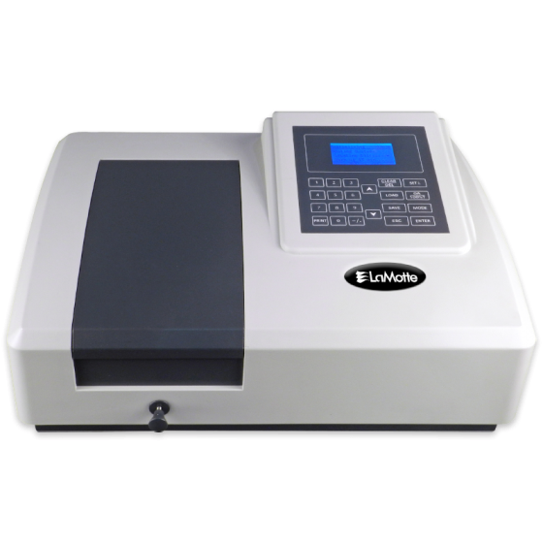

**UV visible spectrophotometer**

DNA concentration can be determined by measuring the absorbance at 260 nm in a spectrophotometer using a UV-transparent cuvette. In molecular absorbance spectroscopy, a beam of ultraviolet or visible light (Po) is directed through a sample. Some of the light may be transmitted through the sample (P). Light that was not transmitted through the sample was absorbed.

**Transmittance (T)-** is defined as the ratio of P/Po.

**Absorbance(A)**- is defined as -log(T).

Both DNA and RNA absorb light at 260 nm, therefore this is a measurement of total nucleic acid. Nucleic acid samples are also typically measured at 280 nm, which is the absorbance peak for protein. Purines and pyrimidines in nucleic acid show absorption maxima around 260nm if the DNA sample is pure without significant contamination from proteins or organic solvents.

A **cuvette-based spectrophotometer** has a horizontal light path where the wavelength-specific light is perpendicular to the sample. Most standard cuvettes have fixed optical path lengths of 1 cm.

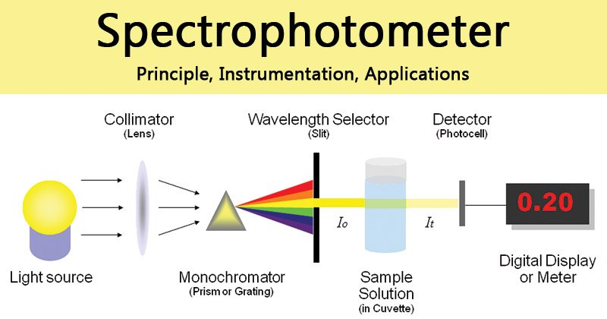

Nucleic acid calculations are based on the **Beer-Lambert Law**,

A = E × b × c

Where,

A = absorbance represented in absorbance units (A)

E = wavelength-dependent molar absorptivity coefficient (or extinction coefficient) units - liter/mol-cm,

b = path length in cm

c = analyte concentration in moles/liter or molarity (M).

For nucleic acid quantification, the Beer-Lambert equation is modified to use an extinction coefficient with units of ngcm/mL. Using this extinction coefficient gives a manipulated equation:

c = A × E × b

Where,

c = nucleic acid concentration in ngμL

A = absorbance in AU

E = wavelength-dependent extinction coefficient in ng×cmμL

b = path length in cm.

The generally accepted extinction coefficients for nucleic acids are:

Double Stranded DNA = 50 ng×cmµl

Single Stranded DNA = 33 ng×cmµl

RNA = 40 ng×cmµl

**Procedure-**

1. Take 1 ml TE buffer in a cuvette and calibrate the spectrophotometer at 260nm as well as 280nm.
2. Add 10 μl of each DNA sample to 900μl TE (Tris-EDTA buffer) and mix well.
3. Use TE buffer as a blank in the other cuvette of the spectrophotometer.
4. Note the OD260 and OD280 values on spectrophotometer.
5. Calculate the OD260/OD280 ratio.
6. The amount of DNA can be quantified using the formula:

**Inferences:**

* A ratio between 1.8-2.0 denotes that the absorption in the UV range is due to nucleic acids.
* A ratio lower than 1.8 indicates the presence of proteins and/or other UV absorbers.
* A ratio higher than 2.0 indicates that the samples may be contaminated with chloroform or phenol. In either case (<1.8 or >2.0) it is advisable to re-precipitate the DNA.

**Precautions-**

* Use gloves to protect samples from nuclease or other contamination found on human skin.
* Ensure the sample vessel is absolutely clean.
* Ensure instrumentation is well maintained.
* Use the same buffer type for blanks and samples.
* Use replicate samples to reinforce accuracy.

**Experiment 3**

**Aim-**

Calculation of extinction coefficient of oligonucleotides either manually or using the software.

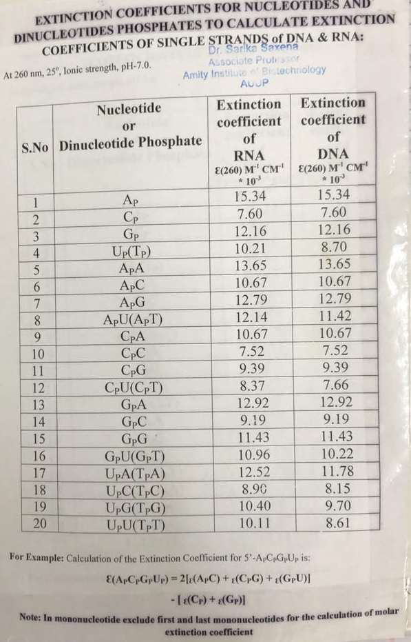

**Eg.** Calculate extinction coefficient of the following DNA sequences:

1. **GGCGGGGCGG**

**Extinction coefficient =** 2((GPG) + (GPC) + (CPG) + (GPG) + (GPG) + (GPG) + (GPC) + (CPG) + (GPG)) – [(GP) + (CP) + (GP) + (GP) + (GP) + (GP) + (CP) + (GP) + (GP)]

= 2(11.43 + 9.19 + 9.39 + 11.43 + 11.43 + 11.43 + 9.19 + 9.39 + 10.22) - [12.16 + 7.60 + 12.16 + 12.16 + 12.16 + 12.16 + 7.60 + 12.16]

=2(93.1) – 88.16

**= 98.04**

1. **GGAGGGGGAGG**

**Extinction coefficient** = 2((GPG) + (GPA) + (APG) + (GPG) + (GPG) + (GPG) + (GPG) + (GPA) + (APG) + (GPG)) – [(GP) + (AP) + (GP) + (GP) + (GP) + (GP) + (GP) + (AP) + (GP)]

= 2(11.43 + 12.92 + 12.79 + 11.43 + 11.43 + 11.43 + 11.43 + 12.92 + 12.79 + 11.43) - [12.16 + 15.34 + 12.16 + 12.16 + 12.16 + 12.16 + 12.16 + 15.34 + 12.16]

=2(120)- 115.8

=**124.2**

1. **GGTGGGGGTGG**

**Extinction coefficient** = 2((GPG) + (GPT) + (TPG) + (GPG) + (GPG) + (GPG) + (GPG) + (GPT) + (TPG) + (GPG)) – [(GP) + (TP) + (GP) + (GP) + (GP) + (GP) + (GP) + (TP) + (GP)]

= 2(11.43 + 10.22 + 9.70 + 11.43 + 11.43 + 11.43 + 11.43 + 10.22 + 9.70 + 11.43) - [12.16 + 8.70 + 12.16 + 12.16 + 12.16 + 12.16 + 12.16 + 8.70 + 12.16]

=2(108.42) -102.52

**= 114.32**

1. **GGUGGGGGUGG**

**Extinction coefficient** = 2((GPG) + (GPU) + (UPG) + (GPG) + (GPG) + (GPG) + (GPG) + (GPU) + (UPG) + (GPG)) – [(GP) + (UP) + (GP) + (GP) + (GP) + (GP) + (GP) + (UP) + (GP)]

= 2(11.43 + 10.96 + 10.40 + 11.43 + 11.43 + 11.43 + 11.43 + 10.96 + 10.40 + 11.43) - [12.16 + 10.21 + 12.16 + 12.16 + 12.16 + 12.16 + 12.16 + 10.21 + 12.16]

=2(111.3) – 105.54

**= 117.06**

**Experiment-4**

**Aim-**

To see the effect of monovalent ion (Na+ or K+) on genomic DNA

**Material required-**

1. Calf Thymus DNA = 1mg/1ml (0.001gm/1ml) or

1000ug/1000ul or

1ug/1ul

1. Cation (Na+) = Stock concentration 2M or 2000mM

= 250ul (Na+ ion from main stock) + 750ul water

1. EDTA Stock concentration: 100mM

Required Conc.= 0.5mM

1. Sodium Cacodylate Buffer Stock Concentration is 1M or 1000mM,

Required concentration of buffer is 30mM

**Theory-**

**Total volume-** 100 ul for 8 cell microcuvette

Required concentration/Stock concentration Xs vol

1mM/2000mM X100ul=0.05ul (we cannot pipette this volume as the lowest capacity of the micropipette is 0.2ul). Hence, it must be prepared sub-stock so we selected 500mM as sub-stock concentration.

1mM/500X100=100/2000=0.2ul

**Note: For lower salt concentration we will use 500mM sub stock and for higher salt concentration, we can directly use 2M salt stock.**

|  |  |  |  |  |
| --- | --- | --- | --- | --- |
| **Water** | **Sodium cacodylate Buffer (pH 7.0)**  **(30 mM)** | **Cation (Na+/K+) in different concentration** | **EDTA**  **(0.5mM)** | **Calf Thymus DNA (5ug)** |
| (100-8) = 92ul | 3ul | 0mM | 0mM | 5ul |
| (100-8.7ul) =91.3ul | 3ul | 1mM (0.2ul) | 0.5ul | 5ul |
| 100-9.5ul = 90.5ul | 3ul | 5mM (1ul) | 0.5ul | 5ul |
| 100-10.5ul = 89.5ul | 3ul | 10mM (2ul) | 0.5ul | 5ul |
| 100-18.5ul = 81.5ul | 3ul | 50mM (10ul) | 0.5ul | 5ul |
| 100-28.5ul = 71.5ul | 3ul | **100mM (Physiological salt conc)** (20ul) | 0.5ul | 5ul |
| 100-18.5ul = 81.5ul | 3ul | 200mM (10ul) | 0.5ul | 5ul |
| 100-28.5ul = 71.5ul | 3ul | 400mM (20ul) | 0.5ul | 5ul |
| 100-38.5ul = 61.5ul | 3ul | 600mM (30ul) | 0.5ul | 5ul |
| 100-48.5ul = 61.5ul | 3ul | 800mM (40ul) | 0.5ul | 5ul |
| 100- 58.5ul = 71.5ul | 3ul | 1000mM or 1M (50ul) | 0.5ul | 5ul |
| Ref solution 100ul water  Or prepare reference for each salt concentration | 3ul |  |  | **NO DNA** |

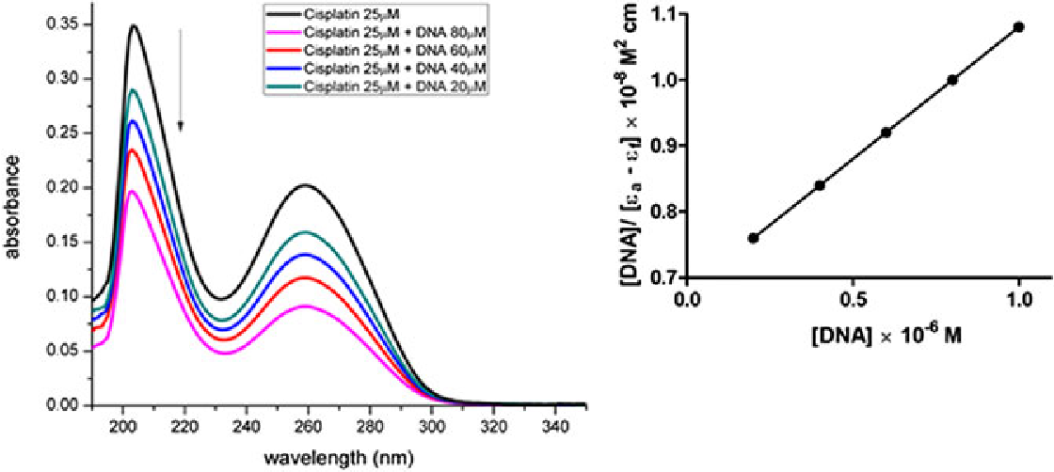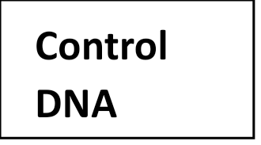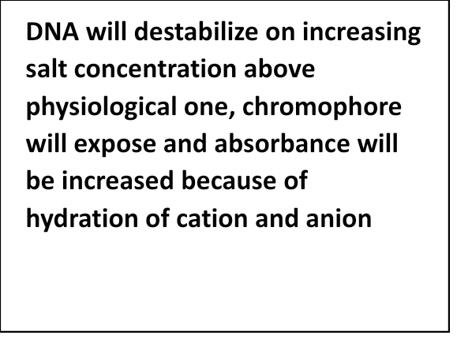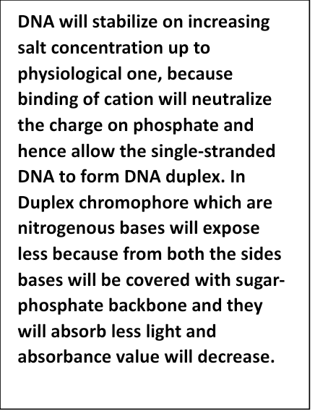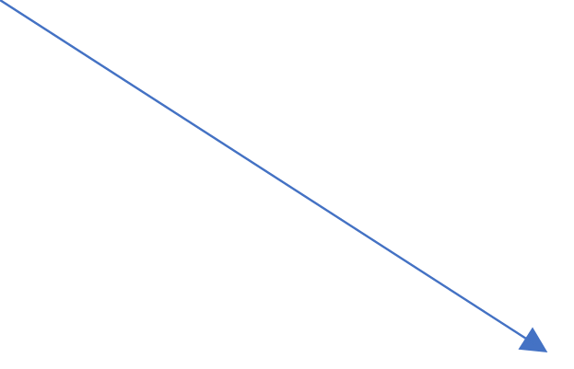

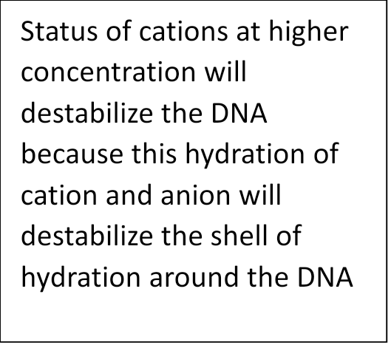

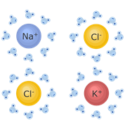

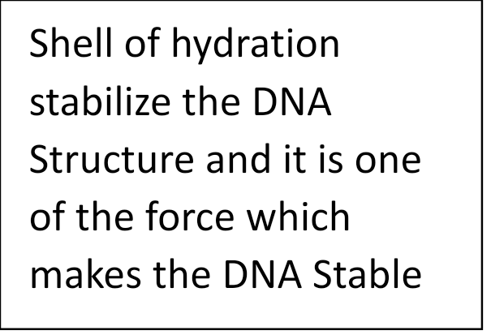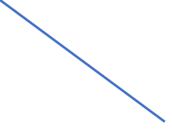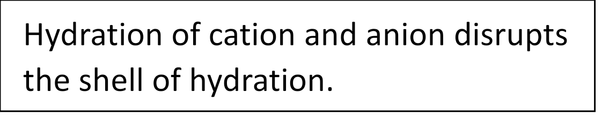

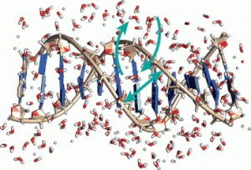



**Experiment-5**

**Aim-**

To see the effect of divalent ion (Mg+2 or Ca+2) on genomic DNA

**Material required-**

1. Calf Thymus DNA = 1mg/1ml (0.001gm/1ml) or

1000ug/1000ul or

1ug/1ul

1. Cation (Na+) = Stock concentration 2M or 2000mM

= 250ul (Na+ ion from main stock) + 750ul water

1. EDTA Stock concentration: 100mM

Required Conc.= 0.5mM

1. Sodium Cacodylate Buffer Stock Concentration is 1M or 1000mM,

Required concentration of buffer is 30mM

**Theory-**

**Total volume-** 100 ul for 8 cell microcuvette

1mM/2000mM X100ul=0.05ul (we cannot pipette this volume as the lowest capacity of the micropipette is 0.2ul). Hence, it must be prepared sub-stock so we selected 500mM as sub-stock concentration.

1mM/500X100=100/2000=0.2ul

**Note: For lower salt concentration we will use 500mM sub stock and for higher salt concentration, we can directly use 2M salt stock.**

|  |  |  |  |  |
| --- | --- | --- | --- | --- |
| **Water** | **Sodium cacodylate Buffer (pH 7.0)**  **(30 mM)** | **Cation (Mg+2/Ca+2) in different concentration** | **EDTA**  **(0.5mM)** | **Calf Thymus DNA (5ug)** |
| (100-8) = 92ul | 3ul | 0mM | 0mM | 5ul |
| (100-8.75ul) =91.25ul | 3ul | 0.25mM (0.25ul) | 0.5ul | 5ul |
| 100-9 ul = 81 ul | 3ul | 0.50mM (0.50ul) | 0.5ul | 5ul |
| 100-9.25ul = 90.75ul | 3ul | 0.75mM (0.75ul) | 0.5ul | 5ul |
| 100-9.5ul = 90.5 ul | 3ul | **1mM (Physiological salt conc)** (1ul) | 0.5ul | 5ul |
| 100-9.75ul = 90.25ul | 3ul | 1.25mM (1.25ul) | 0.5ul | 5ul |
| 100-10ul = 90 ul | 3ul | 1.5mM (1.5ul) | 0.5ul | 5ul |
| 100-10.5ul = 89.5ul | 3ul | 2mM (2ul) | 0.5ul | 5ul |
| 100-11.5ul = 88.5ul | 3ul | 3mM (3ul) | 0.5ul | 5ul |
| 100-13.5ul = 86.5ul | 3ul | 5mM (5ul) | 0.5ul | 5ul |
| 100- 18.5ul = 81.5ul | 3ul | 10mM or 0.01M (100ul) | 0.5ul | 5ul |
| Ref solution 100ul water  Or prepare reference for each salt concentration | 3ul |  |  | **NO DNA** |

**Experiment-6**

**Aim-**

Electrophoresis of DNA.

**Material required-**

1. Calf Thymus DNA = 1mg/1ml (0.001gm/1ml) or

1000ug/1000ul or

1ug/1ul

1. Cation (Na+) = physiological concentration i.e., 100mM=20ul
2. EDTA Stock concentration: 100mM

Required Conc.= 0.5mM

1. Sodium Cacodylate Buffer Stock Concentration is 1M or 1000mM,

Required concentration of buffer is 30mM

1. Drug stock concentration = 100mM

Sub stock concentration = 50mM

|  |  |  |  |  |  |  |
| --- | --- | --- | --- | --- | --- | --- |
| **Water** | **Sodium cacodylate Buffer (pH 7.0)**  **(30 mM)** | **EDTA**  **(0.5mM)** | **Cation (Na+/K+) in physiological concentration** | **Calf Thymus DNA (2ug)** | Denaturation  at  95oC  followed  by  Slow  renaturation  at  4oC | **Drug concentration (DNA:Drug concentration)** |
| (100-5) = 95ul | 3ul | 0mM | 0ul | 2ul | (1:0) 0 uM=0 ul |
| (100-27.5ul) =72.5ul | 3ul | 0.5ul | 20ul | 2ul | (1:0.5) 1 uM=2 ul |
| 100-29.5ul = 70.5ul | 3ul | 0.5ul | 20ul | 2ul | (1:1) 2 uM=4 ul |
| 100-33.5ul = 66.5ul | 3ul | 0.5ul | 20ul | 2ul | (1:2) 4 uM=8 ul |
| 100-37.5ul = 62.5ul | 3ul | 0.5ul | 20ul | 2ul | (1:3) 6 uM=12 ul |
| 100-41.5ul = 58.5ul | 3ul | 0.5ul | 20ul | 2ul | (1:4) 8 uM=16 ul |
| 100-45.5ul = 54.5ul | 3ul | 0.5ul | 20ul | 2ul | (1:5) 10 uM=20 ul |
| 100-37.5ul = 62.5ul | 3ul | 0.5ul | 20ul | 2ul | (1:6) 12 uM=12 ul |
| 100-39.5ul = 60.5ul | 3ul | 0.5ul | 20ul | 2ul | (1:7) 14uM=14 ul |
| 100-41.5ul = 58.5ul | 3ul | 0.5ul | 20ul | 2ul | (1:8) 16 uM=16 ul |
| Ref solution 100ul water  Or prepare reference for each salt concentration | 3ul |  |  | **NO DNA** |  |

**Experiment-7**

**Aim-**

Electrophoresis of DNA with SDS

**Material required-**

1. Calf Thymus DNA = 1mg/1ml (0.001gm/1ml) or

1000ug/1000ul or

1ug/1ul

1. Cation (Na+) = physiological concentration i.e., 100mM=20ul
2. EDTA Stock concentration: 100mM

Required Conc.= 0.5mM

1. Sodium Cacodylate Buffer Stock Concentration is 1M or 1000mM,

Required concentration of buffer is 30mM

1. Drug stock concentration = 100mM

Sub stock concentration = 50mM

|  |  |  |  |  |  |
| --- | --- | --- | --- | --- | --- |
| Water | Tris-HCl Buffer (pH 7.0)  (20 mM) | BSA Protein  (3ug/ul) | SDS | Cation (Na+/K+) in different concentration | EDTA  (0.5mM) |
| 1000-45=955ul | 20ul | 15ul | 15ul | 0mM | 0mM |
| 1000-60.5=939.5ul | 20ul | 15ul | 15ul | 1mM (0.5ul) | 5ul |
| 1000- 72.5=927.5ul | 20ul | 15ul | 15ul | 5mM (2.5 ul) | 5ul |
| 1000-85=915ul | 20ul | 15ul | 15ul | 10mM (5 ul) | 5ul |
| 1000-115=885ul | 20ul | 15ul | 15ul | 50mM (25 ul) | 5ul |
| 1000-150=850ul | 20ul | 15ul | 15ul | **100mM (Physiological salt conc)**  (50 ul) | 5ul |
| 1000-120=880ul | 20ul | 15ul | 15ul | 200mM (10 ul) | 5ul |
| 1000-140=860ul | 20ul | 15ul | 15ul | 400mM (20 ul) | 5ul |
| 1000-160=840ul | 20ul | 15ul | 15ul | 600mM (30 ul) | 5ul |
| 1000-180=820ul | 20ul | 15ul | 15ul | 800mM (40 ul) | 5ul |
| 1000-200=800ul | 20ul | 15ul | 15ul | 1000mM or 1M(50 ul) | 5ul |
| Ref solution 100ul water  Or prepare reference for each salt concentration |  | **NO Protein** |  |  |  |
| 1000-20=980ul | 20ul | 0 | 0 | 0mM | 0mM |
| 1000-25.5=974.5ul | 20ul | 0 | 0 | 1mM (0.5ul) | 5ul |
| 1000-27.5=972.5ul | 20ul | 0 | 0 | 5mM (2.5 ul) | 5ul |
| 1000-30=970ul | 20ul | 0 | 0 | 10mM (5 ul) | 5ul |
| 1000-50=950ul | 20ul | 0 | 0 | 50mM (25 ul) | 5ul |
| 1000-75=925ul | 20ul | 0 | 0 | **100mM (Physiological salt conc)**  (50 ul) | 5ul |
| 1000-35=965ul | 20ul | 0 | 0 | 200mM (10 ul) | 5ul |
| 1000-45=955ul | 20ul | 0 | 0 | 400mM (20 ul) | 5ul |
| 1000-50=950ul | 20ul | 0 | 0 | 600mM (30 ul) | 5ul |
| 1000-65=935ul | 20ul | 0 | 0 | 800mM (40 ul) | 5ul |
| 1000-75=925ul | 20ul | 0 | 0 | 1000mM or 1M(50 ul) | 5ul |